HENNA FOR SALTLEY STORIES
15/02/17
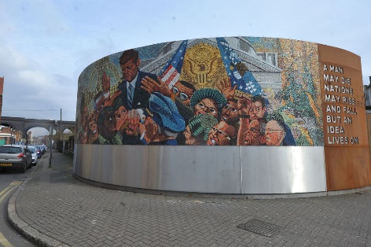
DIGBETH NAMED THIRD HIPPEST AREA IN UK

Digbeth has been voted as third hippest area in the UK after it was named by the Travel Supermarket’s Hip Hang Out. The city was surely voted as this, due to its influential street art almost everywhere. This will bring great tourism because it really brings Birmingham as a whole on the map. Digbeth is filled with creative culture and its unreal urbanity.
Digbeth was also ranked on a variety of things like vintage clothing and solo coffee shops, things that really set the whole kind of hipster ambiance.
Hip Hangout Score 26

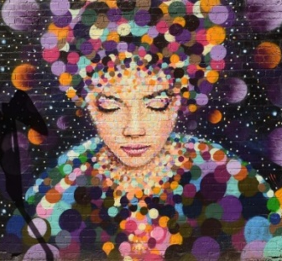
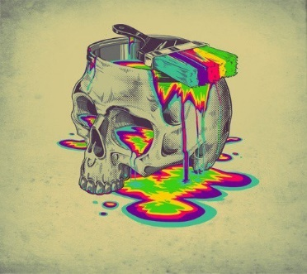
Digbeth’s total Hip Hangout score was 26 only one point away from both the first winner and second. The aim of this is to increase tourism and bring more people to truly enjoy the hipster area, and people can go enjoy the local area of Digbeth containing of many hang outs where people can relax.

The whole area claims of a wealth of cultural and individuality and they are correct, when you step onto the pavement you know it’s something special.

