[](http://r69.cooltext.com/d.php?renderid=227910843209214&extension=png)[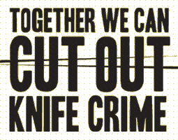](http://www.google.co.uk/url?sa=i&rct=j&q=&esrc=s&source=images&cd=&cad=rja&uact=8&ved=0ahUKEwjluqq6hoPSAhUGbhQKHQKrCzUQjRwIBw&url=http://www.2smart.co.uk/knives/&bvm=bv.146496531,d.eWE&psig=AFQjCNGaQMhffHmyxAZhREfP0h3w5Uf7iA&ust=1486730911853088)[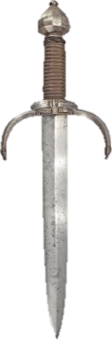](https://www.google.co.uk/url?sa=i&rct=j&q=&esrc=s&source=images&cd=&cad=rja&uact=8&ved=0ahUKEwjPo4m47N_RAhXCCsAKHZLkBpAQjRwIBw&url=https://www.pinterest.com/allennewberry/knives/&bvm=bv.145063293,d.ZGg&psig=AFQjCNFbiImKP3cVd1FyRAwbzNd0qXZhHQ&ust=1485521328316661)

After that the Mother told the story of her dead son who got stabbed by someone.

She was saying that her son loved rapping and making music videos for his songs. However not everyone loved his music; and one person in particular had a problem with him. This person stabbed him numerous times which eventually killed him. The Mother didn’t know this had happened to her son; she was just waiting for him to return home. Then there was a knock on her door and it was the Police who informed her of the news about what had happened with her son. The Mother was in shock. She didn’t know what to do. She couldn’t believe what she had just heard about her son. He was stabbed in the night without anyone by him; all alone in the cold.

Now the Mother tells everyone the story about her son in many schools; informing the students about the pain she went through. Telling students why you shouldn’t stab is her main message as this action has an effect on the family and friends etc. of the victim also. This doesn’t only affect the victim but also the murderer will always have a consequence whether that is going to prison or a detention centre.

17th January 2017

By Rabia News Reporter for Saltley Stories

Recently, there was an assembly about people handling and carrying knives around. This was very educational and very important because it taught young people about what they should and should not do in relation to knives.

Two visitors came to see us; one was a Police Officer and the other was a Mother who had lost her son due to knife crime. The police Officer told us many facts including the average number of people carrying knives and the punishments for doing this. This is important to know as there have been many victims that have been harmed by knives. Also the people that have been stabbing are teenagers; this is illegal and awful for their record as they are young.

The Police Officer told us a story about him injuring himself and how he ended up in a wheelchair. What happened to him has got nothing to do with him getting stabbed.