[](http://www.stanscafe.co.uk/wp-content/uploads/2017/01/The-Tempest-Saltley.jpg)[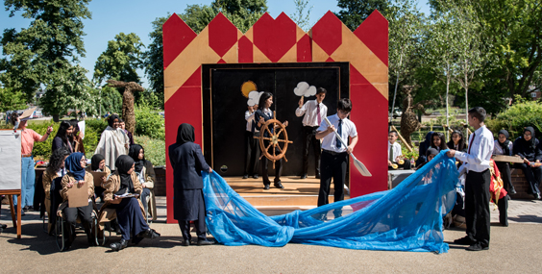](http://www.google.co.uk/url?sa=i&rct=j&q=&esrc=s&source=images&cd=&cad=rja&uact=8&ved=0ahUKEwjHq7iQ7d_RAhWNHsAKHXNjD-UQjRwIBw&url=http://www.stanscafe.co.uk/?cat%3D73&bvm=bv.145063293,d.ZGg&psig=AFQjCNFJaEO8-Ge-AvwvRmCCzFh0-4TLxA&ust=1485521539808368)

By Isha for Saltley Stories.

Last year a special guest visited Year 9 to inform us of an acting project with the company Stan’s Café. We took part in bringing Shakespeare’s *The Tempest* to life and we all had a role to play.

We were told that all of Year 9 would visit Stratford-upon-Avon and act out *The Tempest* in front of a live audience. Loads of pupils started to panic about this, and Sobayda has made the following comments on this time: “When I was informed that we were going to perform my heart just sank! I thought I could never do this, but the teacher who was instructing us told us to believe in yourself”.

Year 9 rehearsed the play for three weeks. They practised and practised and started to feel comfortable when acting in front of others.

Then time came for the Year 9 to go to Stratford-upon-Avon the students were confident and ready. As a result, when everyone performed; they all smashed it! Lucy from Stan’s Café has made the following comments on the whole experience: “When I came to Saltley Academy I was really scared because the pupils were complaining that they could not do it and that they didn’t like acting. But they have worked so hard and have performed so well. I’m really happy for them and would like to send my congratulations to all”.

Saltley pupils now eagerly wait to see which Shakespearean play they will be performing next! Watch this space…

**The Tempest**