John Agard’s Appearance Hits Headlines In Saltley School
On Tuesday 1st May a world-wide internationally famous poet who goes by the name ‘John Agard’ came and gave Year 10 an unforgettable experience which will help them pass with flying colours in their literature exam coming up very soon.
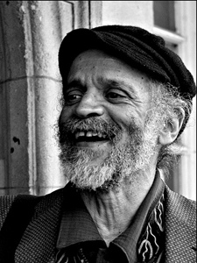
He began and spoke about his childhood and heritage and how it was robbed from him at such a young age and the difficulties it had caused him later on in his life being a Portuguese/Guyanese boy living in British Guyana and how he was taught British nursery rhymes and British history.
Strangely he remembered his first sentence in his history book being about Christopher Columbus as he also mentions him in his poem ‘Checkin Out Me History’:
’Dem tell me ‘bout Columbus and 1942’
John Agard read 3 of his well-known poems which were: Checkin’ Out Me History, Kettle and Half-Caste. In which he had said poems are best read aloud and ideas can be thought

Read aloud and ideas can be thought anywhere even in the shower.
He also inspired everyone to everyone take up poetry and that they all do not have to be only thing and they can be many things it all depends on if they enjoy it.
He then closed off his amazing performance answering performance by answering pupil’s questions in full detail and depth.
https://www.youtube.com/watch?v=LFV_06_UidI

By Asley Ahmed

